**Notes on Salesforce**

https://trailhead.salesforce.com/trails/lex_admin_implementation

Salesforce lighting is the newer version of salesforce classic, a cloud based (SaaS) CRM available on both desktop and mobile (salesforce app) that is focused on sales. It allows users to track metrics/data as well as communications. You are able to records together to show related data.

Stores data into objects and records.

**Define terms**

Record – item you are tracking in your database

Field – place you store a value

Object – a table in the database

Org – where data, config, customisation goes. “your instance of Saleforce”

App – set of fields, objects, permissions, and functionality

Makes bad to okayish jokes

**Standard Objects**

Accounts – companies you are doing business with, individual version of this called Person Accounts

Contacts – people who work at an Account

Leads – potential prospects, used for team selling

Opportunities – quantified leads you’ve converted. When converted you make an account and contact

**Custom Objects**

Allows the creation of custom objects and processes.

Someone makes a request -> fills in a form -> form gets added to custom object -> get email/notification of request -> make dashboard to track and view requests

**Lightning Experience**

Pages in Saleforce optimised for sales use.

More bad jokes

Unique to each sales rep with custom alerts and interactive assistant.

Navigation bar for pages/apps

Notes tool, relate notes to multiple records

Search capabilities

**Home**

Home page

Add monitors, assistant, news etc.

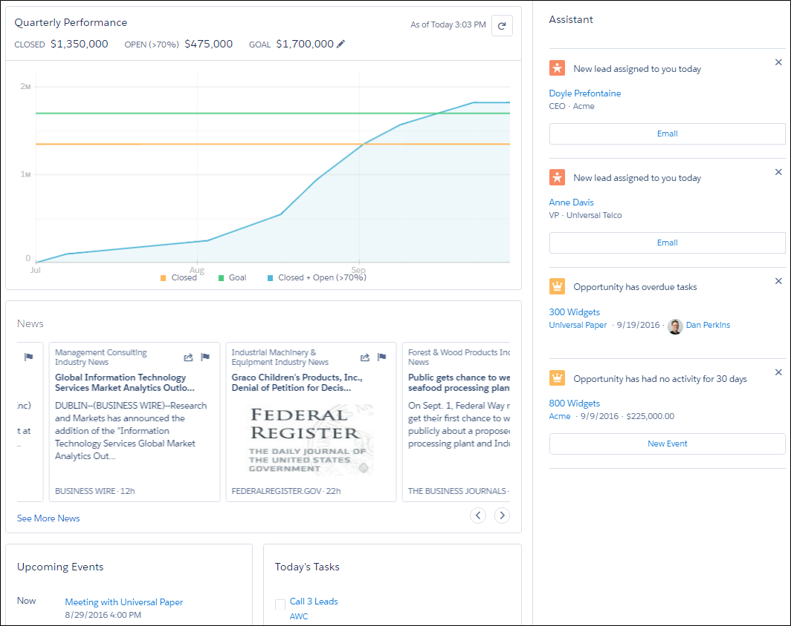

**Opportunity Workspace**

Sales process, customised coaching scripts, insights, timelines, create records

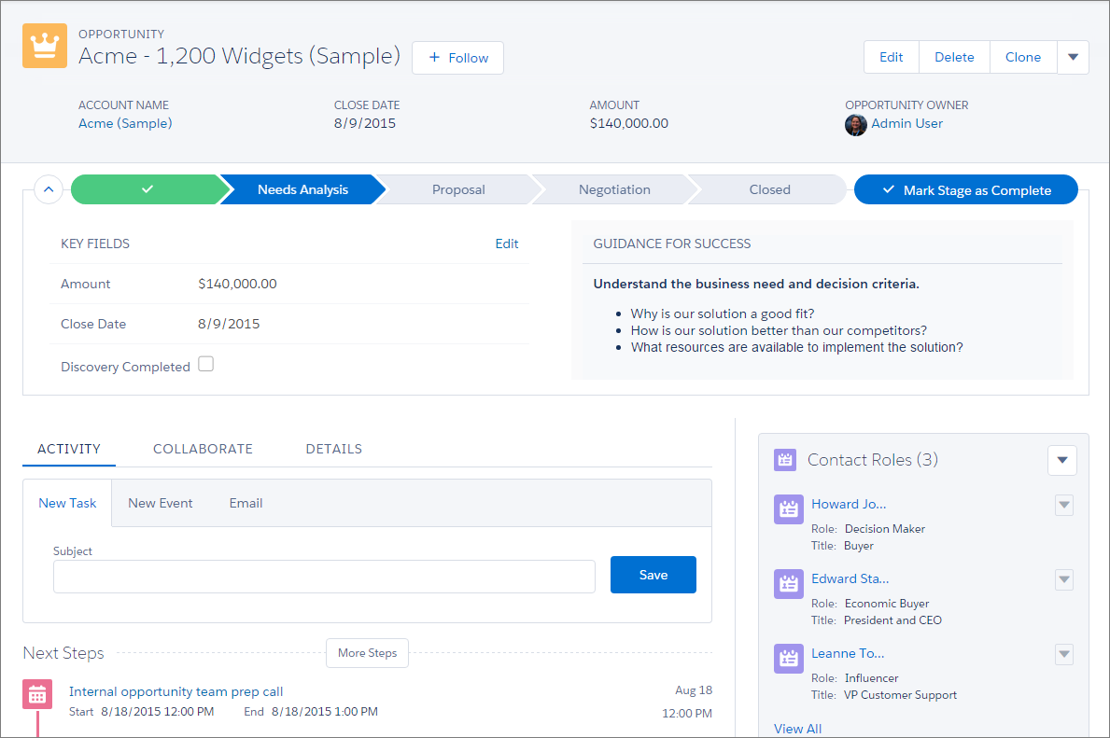

**Accounts and Contacts**

Optimised for referencing, as unlikely to need to update often

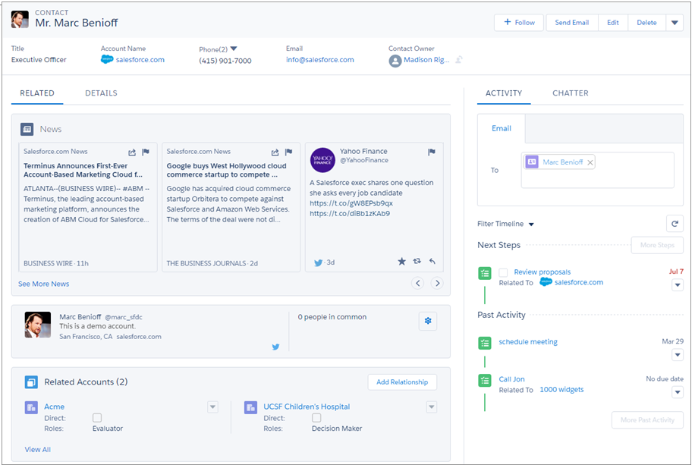

**List views**

Apply filters, customised lists, list view charts

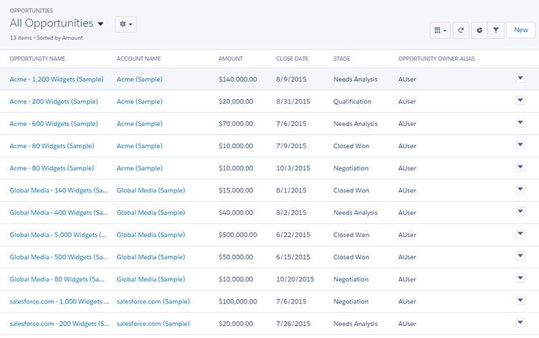

**Opportunity Kanban**

Visualisation tool for opportunities, review deals organised by stage in pipeline

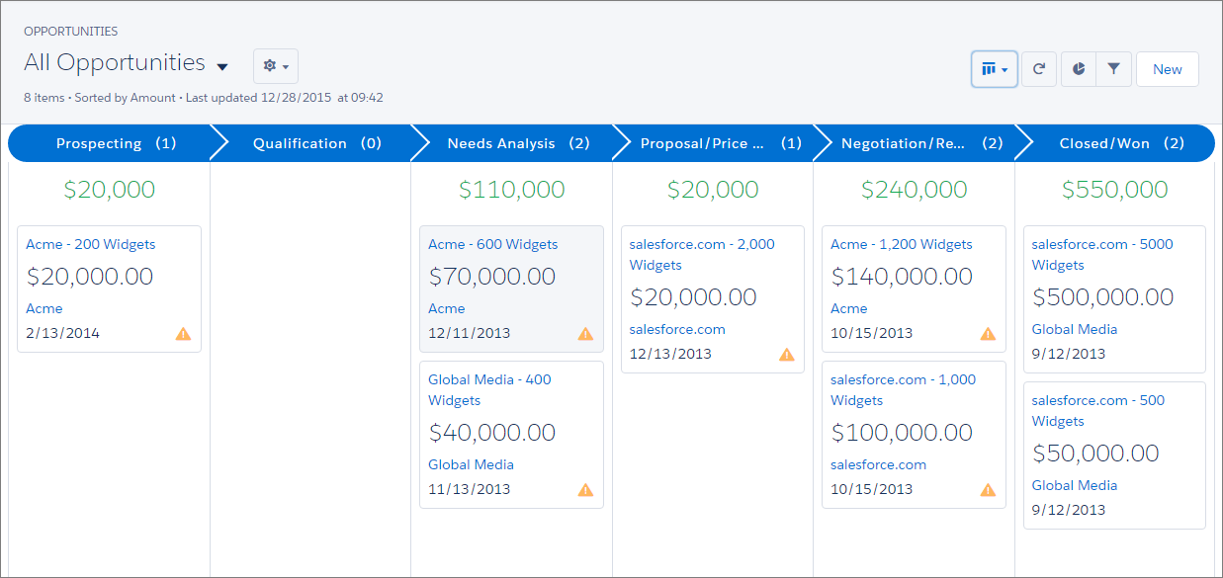

**Reports and Dashboards**

Reports are a list of records that meet set criteria that you define. Can apply complex filtering logic…

Excel stuff basically

Able to edit/customise dashboard

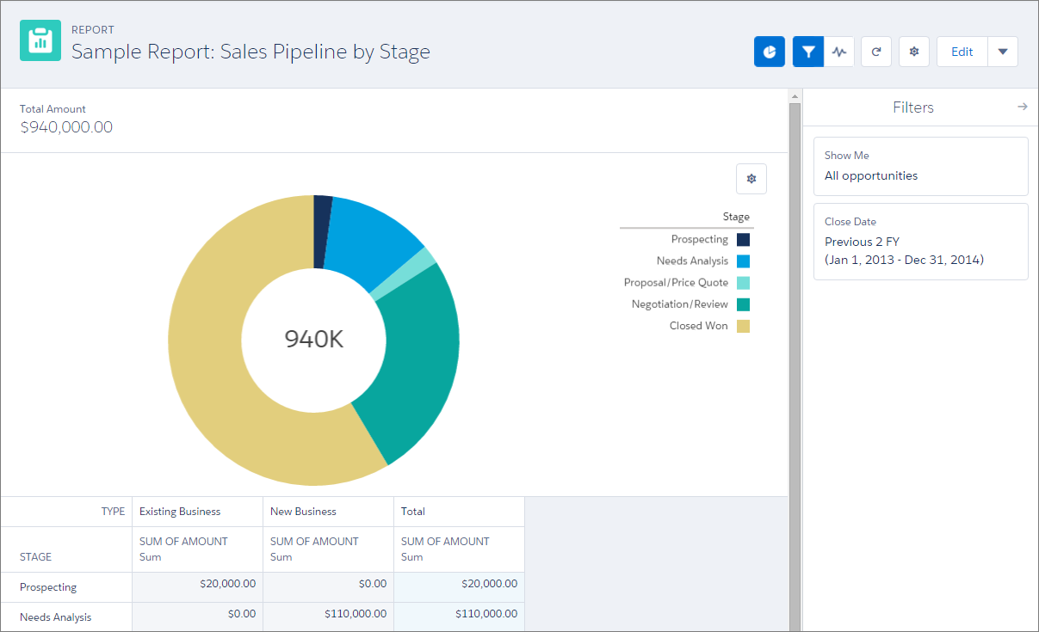

They had a good joke

**Navigation**

**Nav bar**

Drop down menu dependant on tab

1. App name
2. Colours and branding
3. App launcher
4. Drop down menu

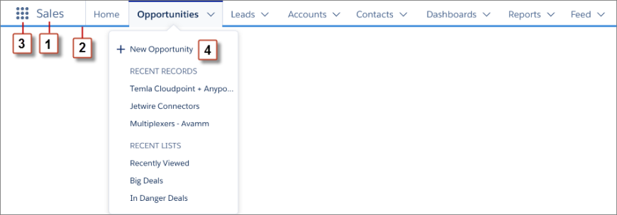

Search for apps in app launcher

All apps – shows custom, standard, lightning experience and connected apps. Can be connected with 3rd party apps e.g. gmail, google drive, office 365 etc.

All items – homepage, feed, tasks, events, objects, custom tab types. shows items independent of the app

Authorised users can go to appExchange

Can customise default layout of apps

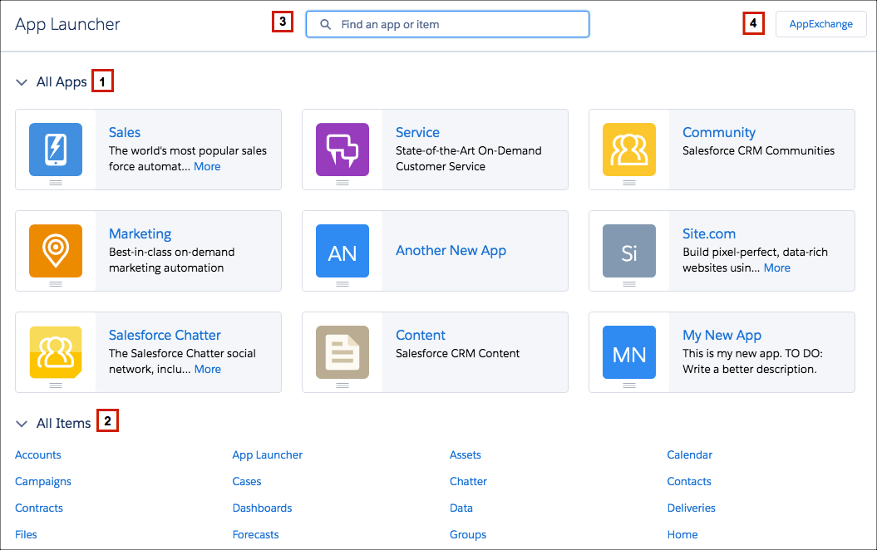

**Set-up**

Customise and config org, support users, make functionality etc.

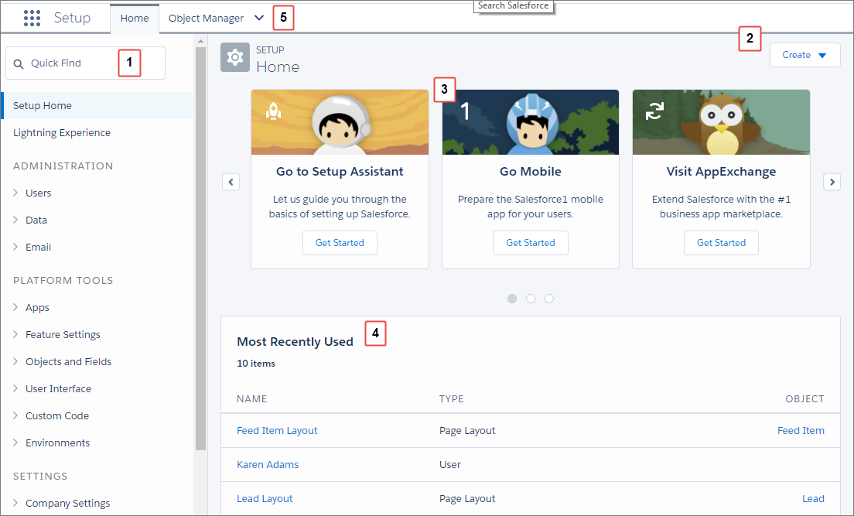

1. Search tool for pages in setup menu
2. Create menu: quick access to common create items
   1. New users
   2. Multiple users
   3. Customer object
   4. Custom tab
   5. Email template
   6. Workflow process
3. Carousel: quick access contains useful tools
   1. Open object manager and customise records, fields, layouts
   2. Launch setup saleforce
4. Recently used list
5. Object manager: contains standard and custom objects

**Search**

Global search box top of every page

Incremental search

Spell correction on no results, synonyms are checked, plural version of words

Has operators, exact phrase searches and wildcards

Global search with filters to find stuff

**Analytics**

<https://trailhead.salesforce.com/trails/wave_analytics_explorer>

standard analytic stuff

create dashboards for continuous monitoring of metrics

add data to a dataset, then run analysis on that

did some analysis on data sets

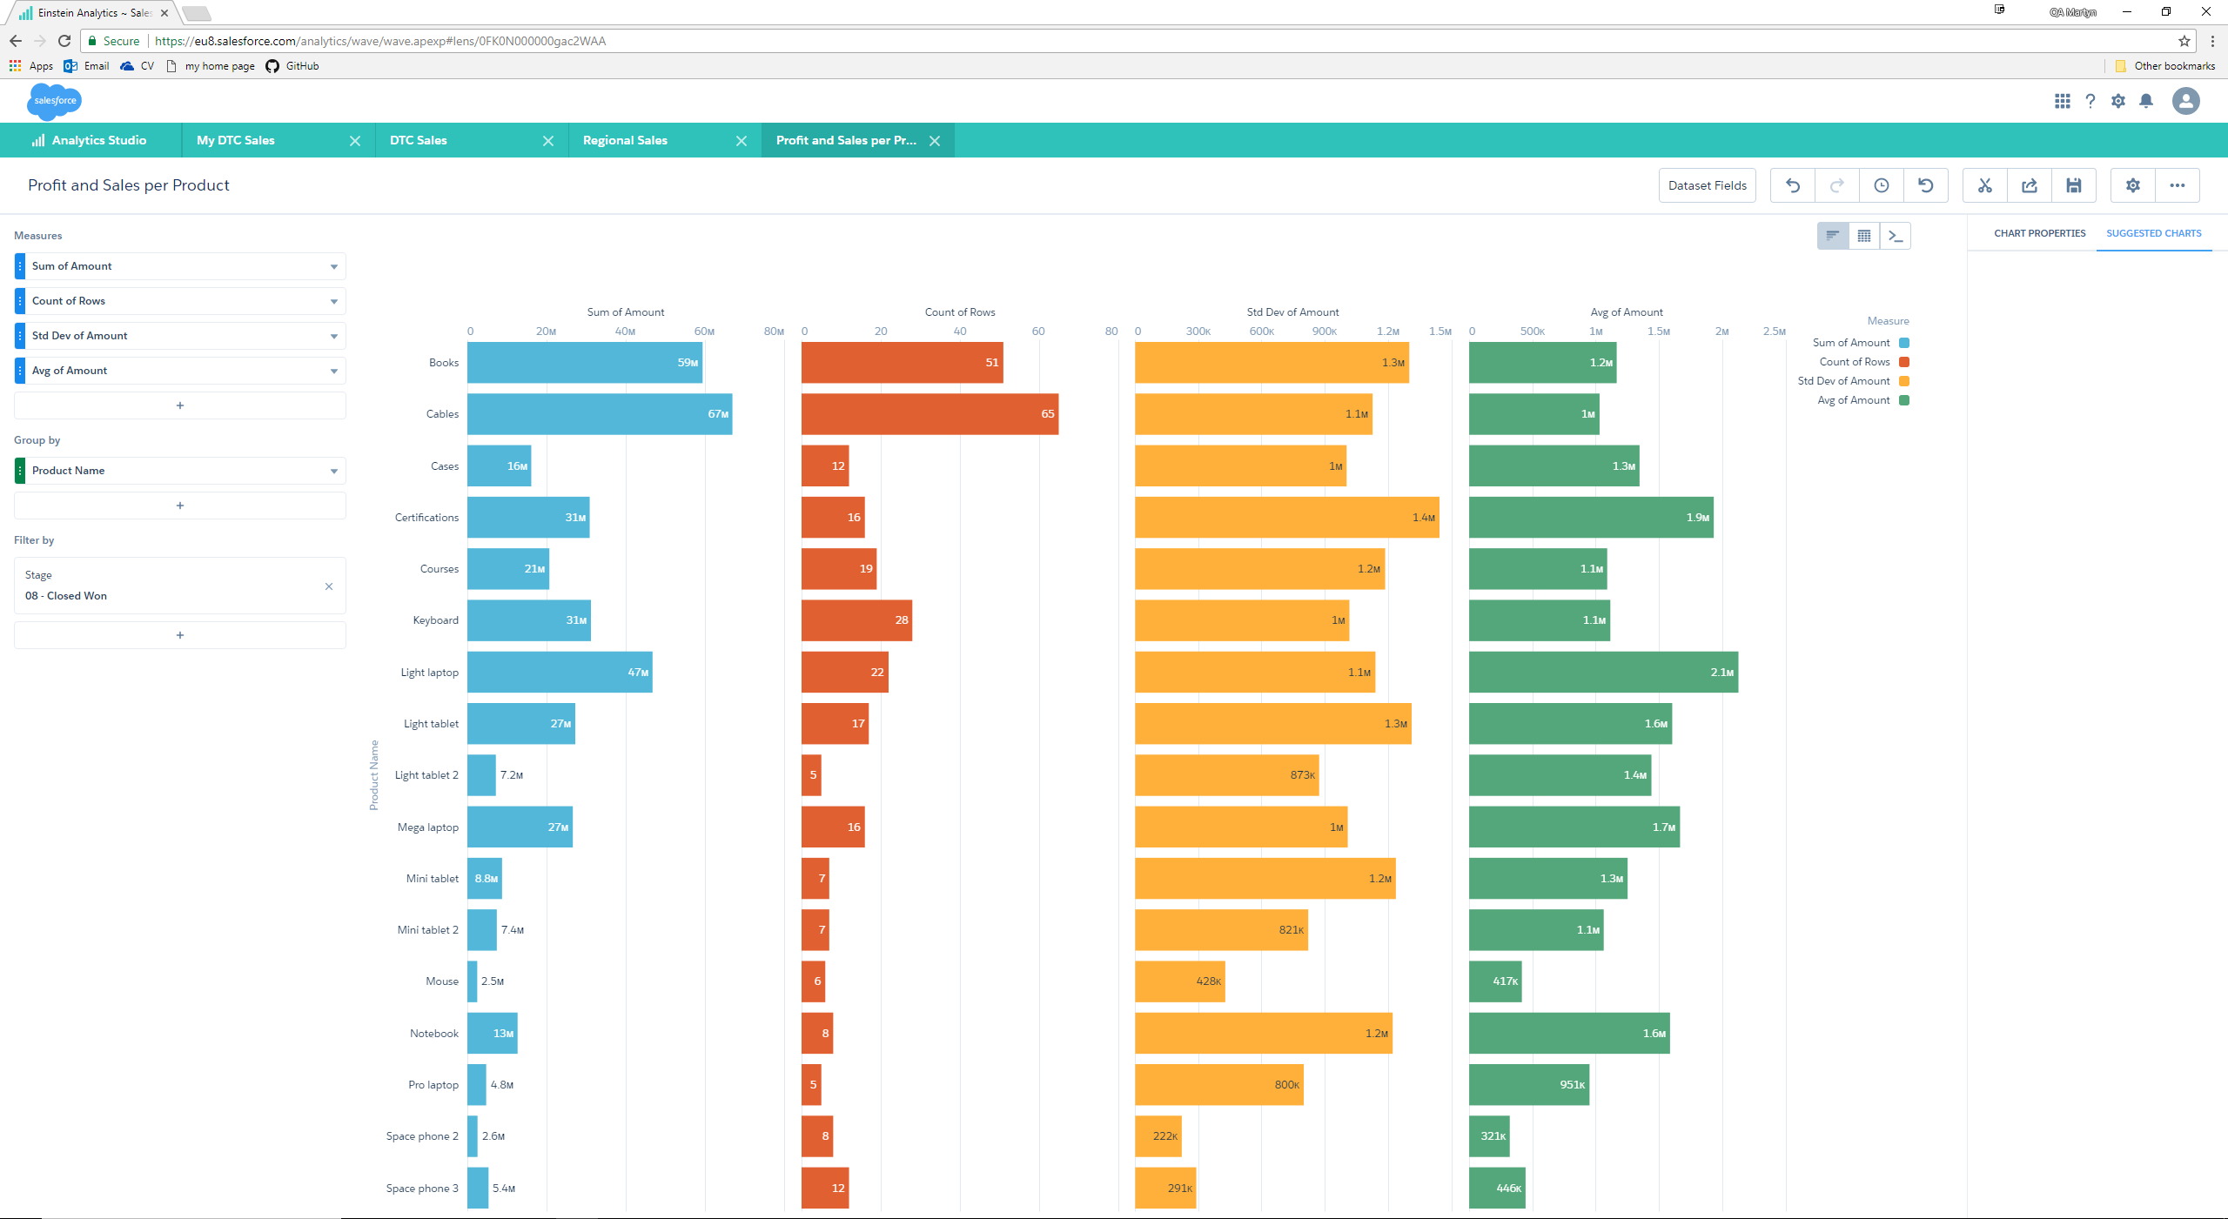

(left 2) Shows the total amount from each product, and the number of sales for each product.

(right 2) Shows the average amount of for a sale of each product, including only those sales that have been finished, and gives the standard deviation for the mean.